**Industrial and agricultural ammonia point sources exposed**

Because of its role in the formation of particulate matter, atmospheric ammonia is a key driver of air quality, with major impacts on human health and life expectancy. Excess ammonia also affects the entire biosphere through acidification and eutrophication of ecosystems and impacts indirectly climate. Anthropogenic NH3 emissions originate mainly from agricultural, domestic and industrial activities, but both the total budget and the partitioning between the sources are highly uncertain, on all spatial scales.

The underlying reason for this uncertainty is that NH3 has a short atmospheric lifetime, which in turn leads to very large variations of its concentration in space and time. The sparse surface monitoring networks that are in place are therefore inadequate to monitor ammonia on representative spatial scales. This limitation of the global in-situ monitoring system, which is a major obstacle to evaluate the impact of planned or implemented policies for air quality management, is progressively being alleviated with the availability of global satellite measurements.

For over 10 years, the IASI instruments launched on board three successive Metop satellites have been providing scientists with global data on various atmospheric components, including ammonia. How does it work? IASI, flying at an altitude of 817 km, measures the infrared radiation emitted by the Earth at different wavelengths (in the form of a spectrum). Once emitted by our warm terrestrial crust, this radiation is absorbed by the gases present in the atmosphere before reaching the satellite sounder. Each atmospheric constituent has a specific spectral signature -similar to a fingerprint- that allows its unambiguous detection. The magnitude of its absorption is related to its concentration.

There exist a range of sophisticated tools to retrieve, from the IASI spectra, the concentrations of the most important atmospheric gases, among which for instance carbon dioxide and ozone, but also ammonia. However, ammonia concentrations are in general very small. It is only ten years ago, that we have shown that IASI was able to measure ammonia.

Using almost a decade of IASI measurements and a special averaging technique, we have generated the first high-resolution map (~1km²) of the global atmospheric distribution of ammonia. Analysing the map, country by country, we found strong but localised sources, also called “hotspots”. In total, more than 200 of such hotspots were identified and categorized. It was really surprising to see that most of these originated from industry. In many cases it was possible to pinpoint the exact location of the factory responsible for the emissions. These factories, located in all parts of the world, were mostly associated with the synthetic production of fertilizers. The other hotspots found are related to intensive agriculture, especially animal farming such as massive cattle feedlots -containing thousands of animals enclosed in confined quarters-, egg production centers, pig farming etc. We found these in particular in Central and Northern America.

The emission fluxes of each hotspot were quantified and revealed that emissions from industrial and agricultural point sources were drastically underestimated in the current bottom-up inventories, with 2/3 of the identified hotpots completely absent. The IASI era (2007-…) also allows observing changes in human activities. Opening and closure of industrial sites were identified in Eastern Europe and China, as well as agriculture in transition in South America.

Space measurements point to the urgent need to revise current ammonia inventories. This is critically needed for assessing the health and environmental impacts of ammonia pollution and for implementing suitable nitrogen management strategies. Our study also demonstrates the coming of age of ammonia satellite measurements, which will be used in a near future to monitor the effect of legislations on ammonia emissions, and therefore be a powerful auditing tool for policy-makers.

**Scientific contacts :**

**Martin Van Damme**

Université libre de Bruxelles (ULB), Service de Chimie Quantique et Photophysique

martin.van.damme@ulb.ac.be

**Lieven Clarisse**

Université libre de Bruxelles (ULB), Service de Chimie Quantique et Photophysique

[lclariss@ulb.ac.be](mailto:lclariss@ulb.ac.be)

**Link:** [Interactive map of atmospheric ammonia emission sources](https://www.ulb.ac.be/cpm/NH3-IASI.html).

**Reference:** Van Damme, M., Clarisse, L., Whitburn, S., Hadji-Lazaro, J., Hurtmans, D., Clerbaux, C., Coheur, P.-F. Industrial and agricultural ammonia point sources exposed. Nature, doi: [10.1038/s41586-018-0747-1](https://doi.org/10.1038/s41586-018-0747-1), (2018).

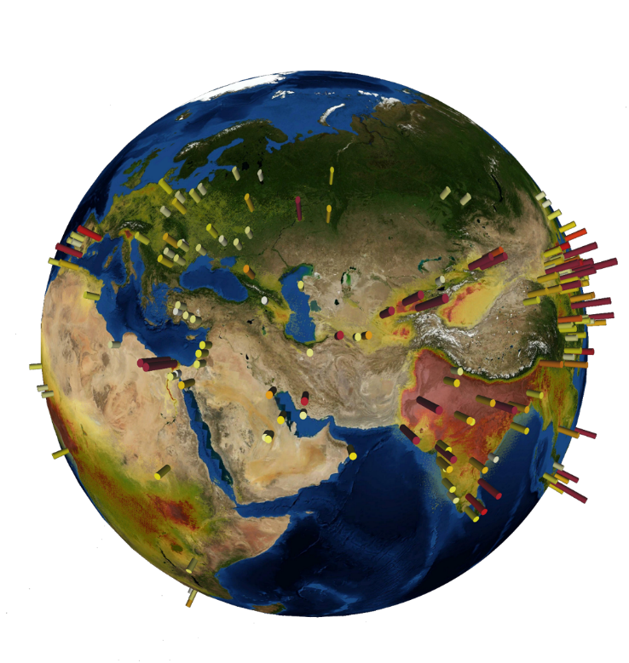

**Ammonia emission fluxes calculated based on almost a decade of IASI measurements.**

Map data from Google Earth, Landsat/Copernicus

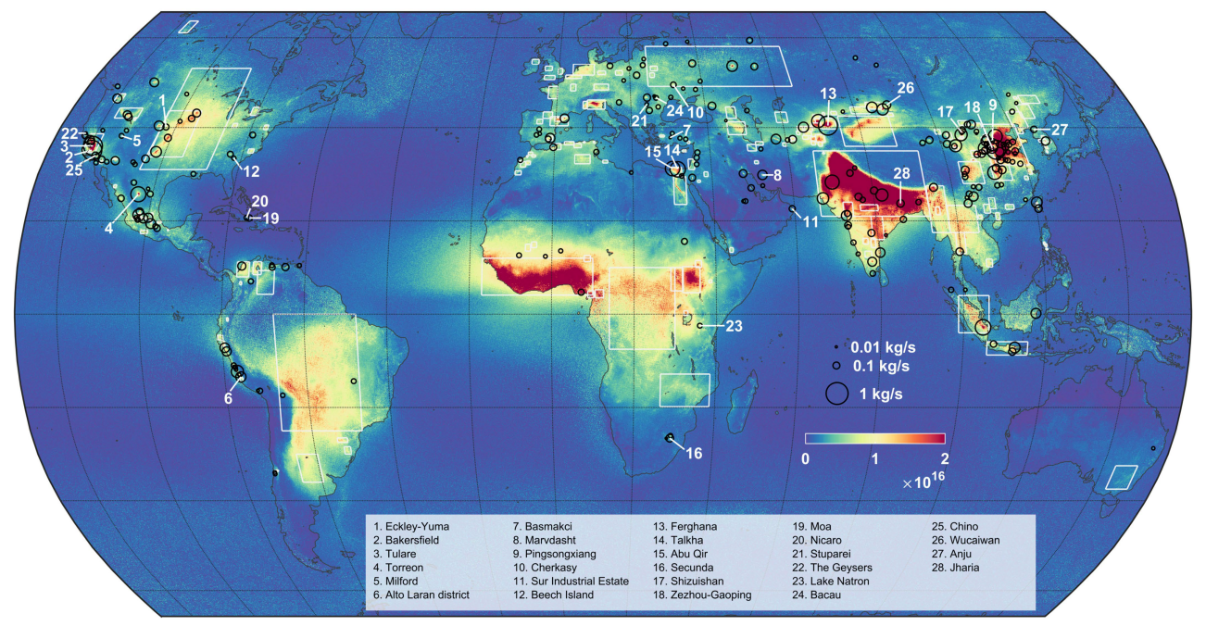

**Global oversampled average distribution of ammonia (molecules/cm2) using almost a decade of IASI satellite measurements. Hotspots are identified with black circles which size quantifies the satellite-derived emission flux (kg/s). Large source regions are indicated with white rectangle.**

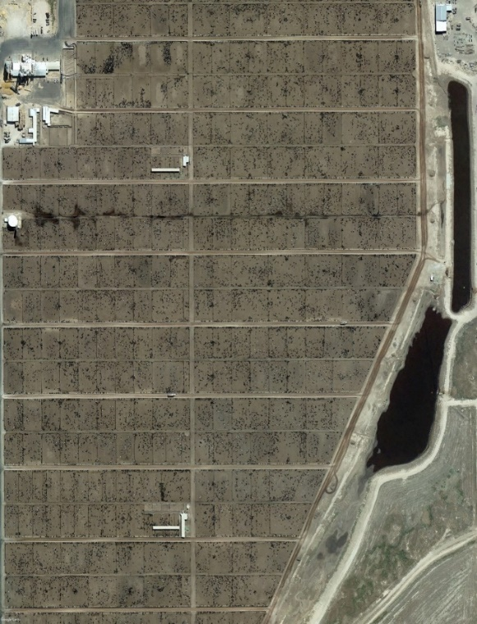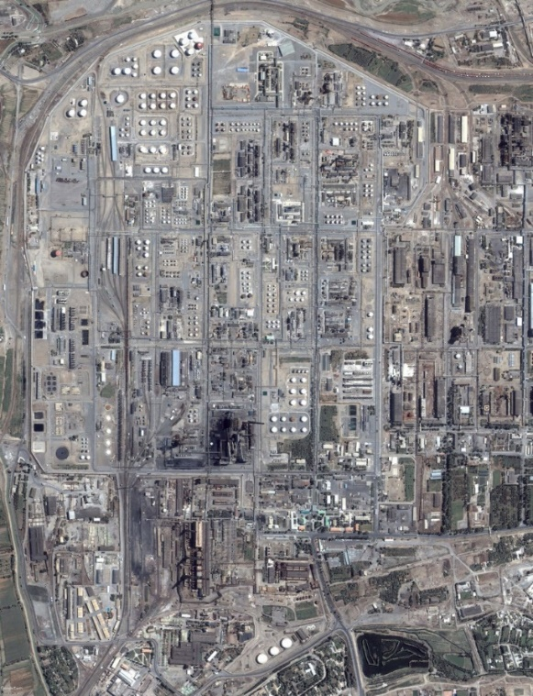

**This aerial photograph shows a synthetic fertilizer production complex in Ferghana (Uzbekistan). It is an example of an industrial point source that releases prodigious amounts of NH3. Until now the importance of these emissions has been drastically underestimated.**

Map data from Google Earth, Landsat/Copernicus

**This aerial photograph shows a cluster of cattle feedlots (Tascosa Feedyard in Texas, US) and their associated waste lagoon in the centre. It is an example of an agricultural point source that releases prodigious amounts of NH3.**

Map data from Google Earth, Landsat/Copernicus